1. Select your region (ex: Ireland)

**Lab 1 : Amazon EC2 Demo**



1. Choose EC2 service in the AWS console

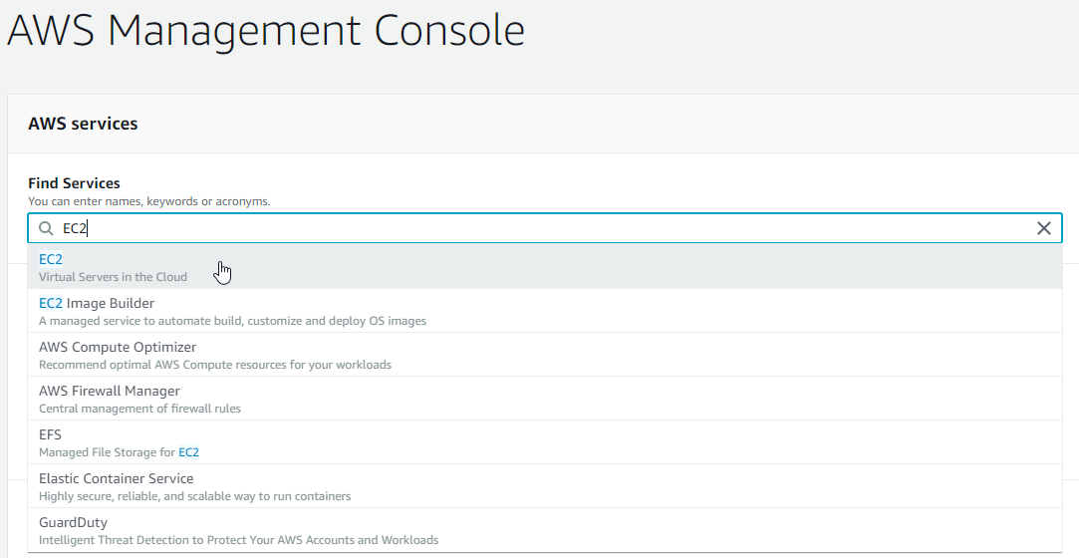

1. Create your first EC2 Instances

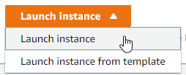

1. Choose and Amazon Machine Image (AMI) – Amazon Linux 2 AMI



1. Choose an Instance Type t2.micro (Free Tier eligible)



1. Network -> Default VPC (If doesn’t exist Create a new default VPC)

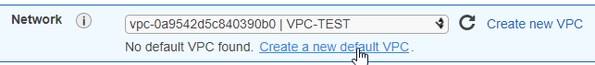

1. Enable Auto-Assign Public IP



1. Go to the bottom of the page and add User-Data available here:

<https://github.com/BastosAWS/esgi-aws/blob/master/Lab-1/user_data.txt>

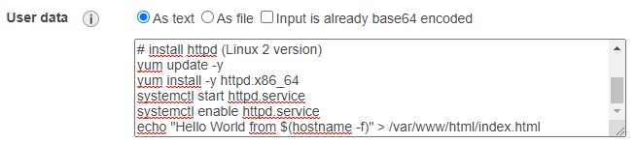

1. Add Tags



1. Configure Security Group

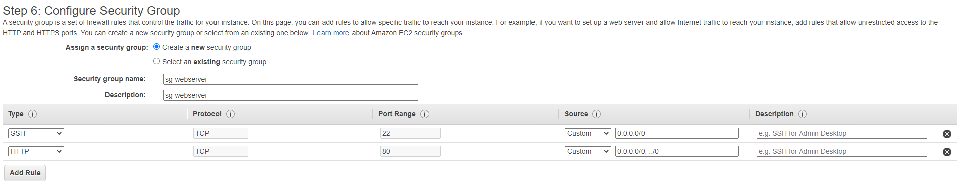

1. Create Key Pair for access to Instance throught SSH

/!\ Don’t forget to Download Key Pair /!\

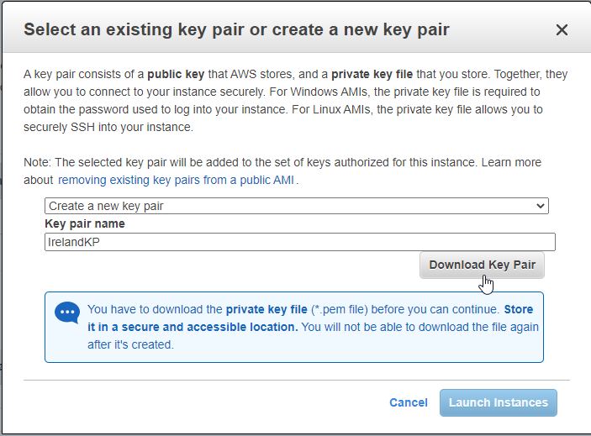

1. Launch Instance



1. Access to the Website

Find Public IP or DNS Public of your instance:

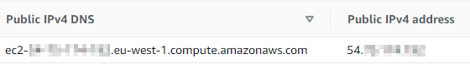

Copy the DNS or Public IPv4 on your browser and see your first Website hosting in the AWS Cloud !

*For more:*

*See all parameter you can get on your instances/*